Canceling a Lab Reservation

Note: The title of this document is hyperlinked to a screen cast for the directions for deleting a reservation.

- Log on to your ASD Google account.
- In the upper right-hand corner of the screen, find this (you should see your name): 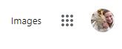
- Click on the Google “waffle” or grey nine square. This will appear:
4. Click Calendar.
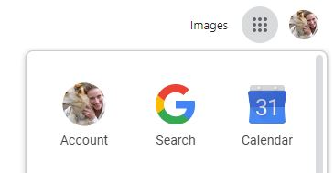
- You will need to find the date in which you made the original reservation—use the Date Toolbar or the Calendar on the left hand side of the screen: 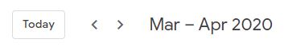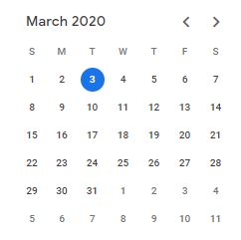

- Once you have selected the date, you will see your reservation(s). You will NOT see other staff members’ reservations. Depending on the view you have set up in Google calendar, a different screen will appear (I have included the Schedule View and the Week view; images are in corresponding order):
OR
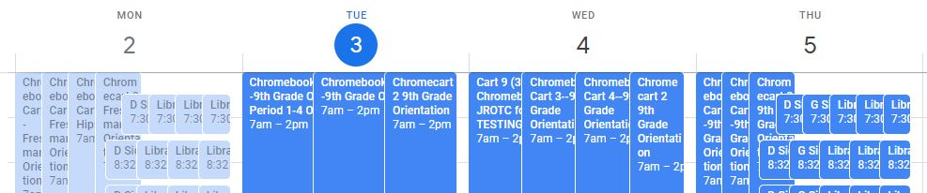
- Click on the reservation you would like to delete.
The icons will allow you to edit your reservation (the pencil), delete your reservation (garbage can), or invite others to your reservation (envelope). The other three dots open up a whole can of worms I will let you explore on your own!

Dismiss = No, I do not want to delete my reservation—TAKE ME BACK!

Don’t Send = Yes, I do want to delete my reservation but do not send me a confirmation email.

Send = Yes, I do want to delete my reservation and send me and any others included on this reservation a confirmation email.
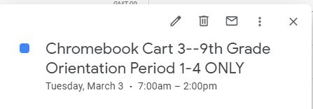

- The below message window will open.
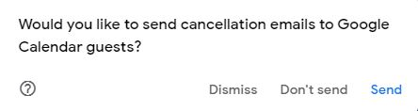

- If the cancellation is last minute, please email Service High letting the staff know there is a lab now available. It is the cool thing to do.

No staff reservations were deleted with the creation of this document !

