Reserving a Computer Lab, Chromebook Cart, Library Area, or Conference Room

Note: The title of this document is linked to a screen cast of the directions; there screen casts are also on the main reservation page.

- Log in to your ASD Google account.
- Make certain you are not logged on to a personal Gmail account.
- Open a new tab, and go to the Service High Lab Reservations website: http://servicehighlibraryak.weebly.com/service-staff-reservations-page.html
- Scroll through the page until you find the room or cart you want to reserve. The name of the lab will a blue hyperlink to the actual reservation page. 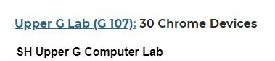
- The lab calendar webpage will open.
- In the upper left corner, there will be a toggle button to change the date. Change the date to the day/week you would like to reserve the lab: 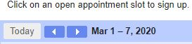
- Once you have selected the week in which you want to make a reservations, look for a grey button on the date you want that shows the name and/or period of the lab/area/cart:
- If the space looks like this: the lab/cart/area is not available to reserve.
- Once you click a grey button, a confirmation box with fields to add information and save your reservation.

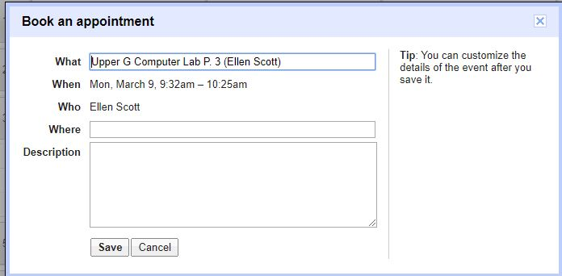
Help your colleagues! Make certain your name (it auto-populates if you use you ASD Google account) shows up in this field. You can also indicate if you only need a chrome cart certain periods; other staff members will see the information and can coordinate sharing the resource with you!
- You will receive an email to your ASD confirming your reservation (unless you did not use your ASD Google account; then, check your personal Google account).

